***SGD LAB EXP – 3B***

**Name** : Aditi Chhajed; **Reg. No.** : 221081009

**Branch** : IT ; **Course Instructor** : Prof. Vedashree Awati

Name : Aditi Chhajed

Reg.No : 22108100

***Aim:***

*To write spatial queries using spatial functions like ST_X, ST_Y, ST_Touches,ST_Area etc.*

***Implementation:***

1. *Creating a database first.*

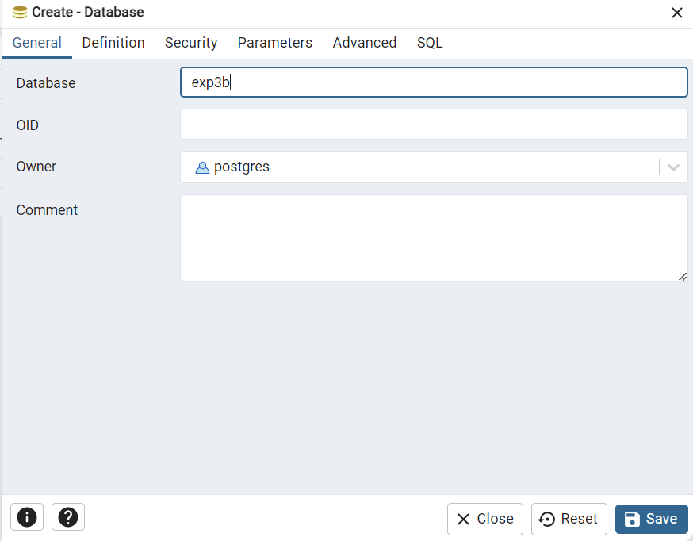

1. *Establish connection.*

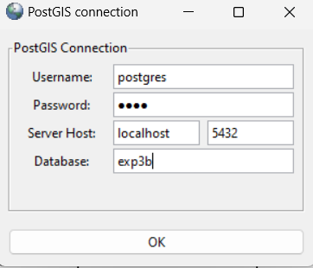

1. *Import Shapefiles*

*Navigate to c:\Program Files\PostgreSQL\15\bin\postgis gui and run*

*executable file shp2pgsql-gui.exe*

*● Click on view connection details*

*● Enter username as postgres, password, server host as localhost and port*

*as 5432 and database name is the same as that was created above in*

*step A.1. After clicking on OK, it should give a message connection*

*succeeded.*

*● Select the add files option and select the shapefile. 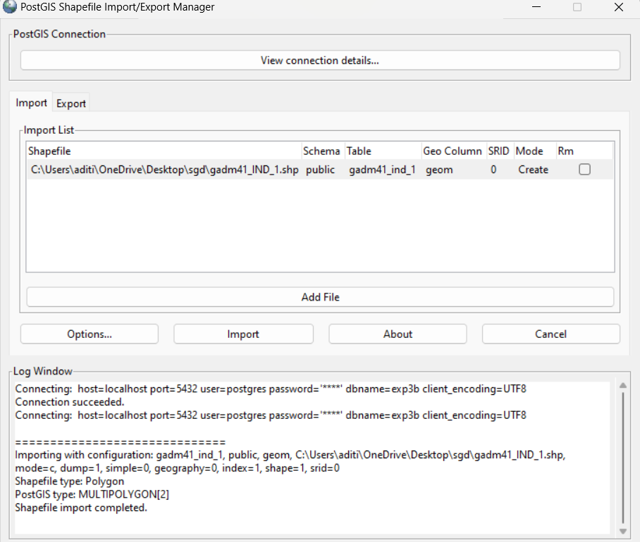*

*Checking the loaded sql file.*

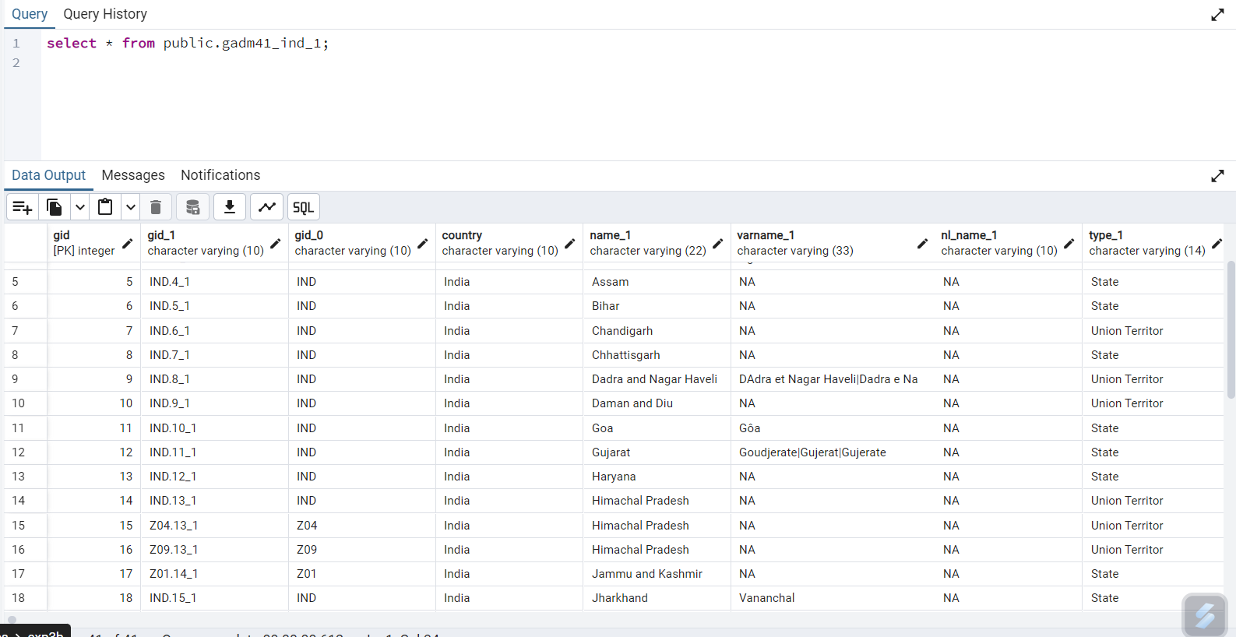

***Execution :***

1. *Find names of all the states which are neighbors of Maharashtra.*

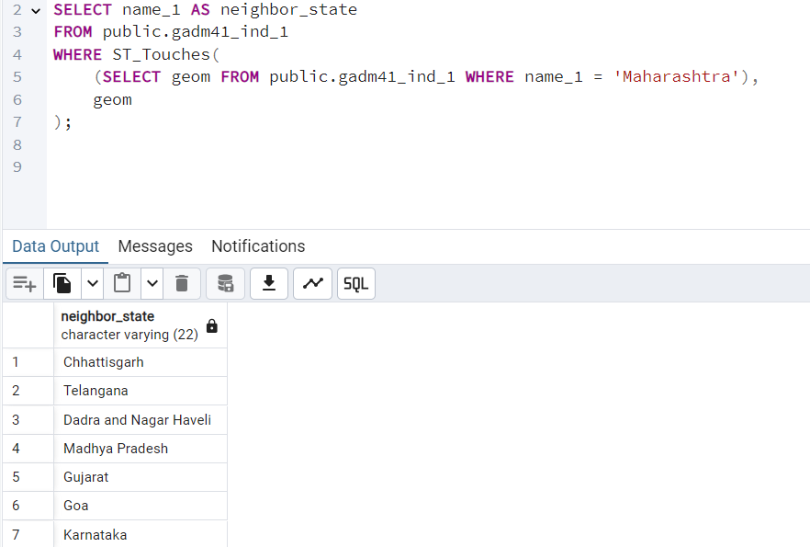

1. *Find states that are ~~315~~ km 100km away from ~~Delhi~~ Maharashtra****.***

***(changes made after discussing with the faculty)***

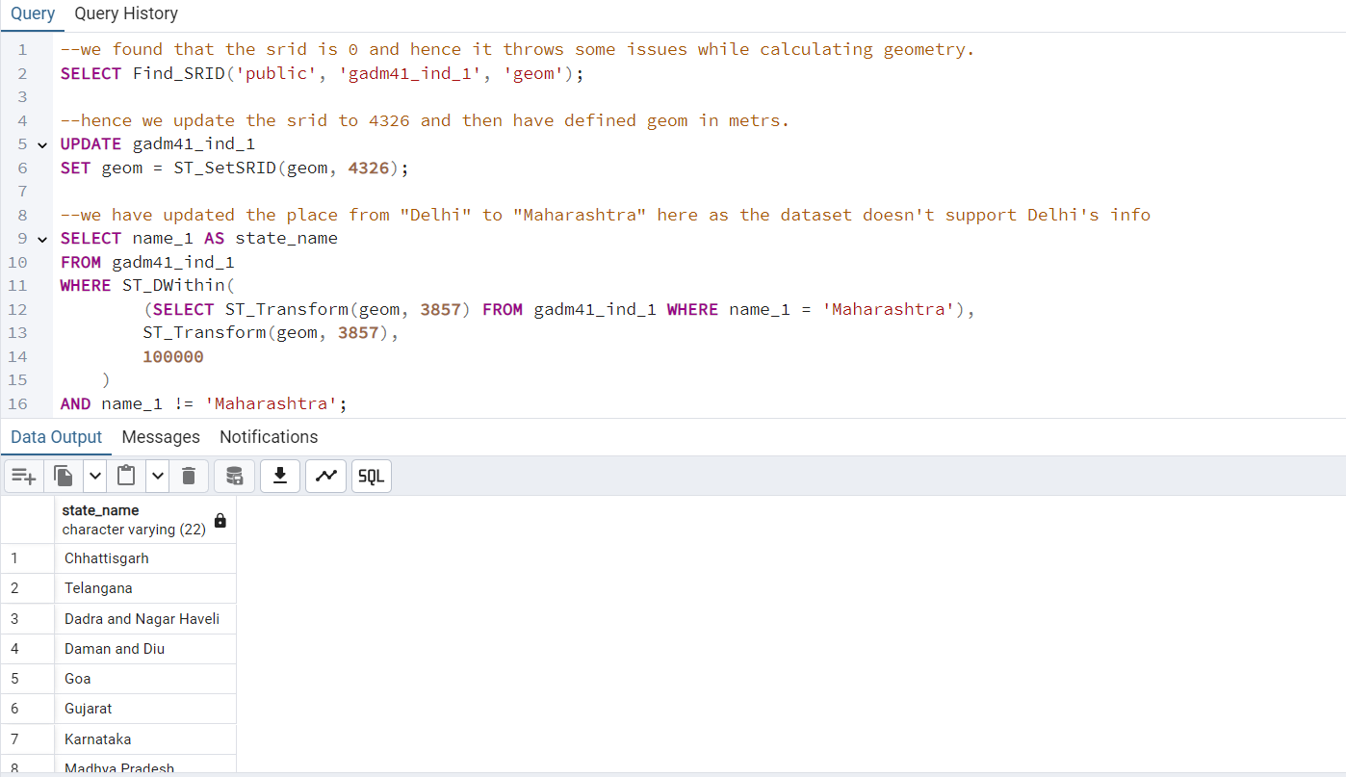

1. *Find the distance of all cities from ~~Kolkata~~ Daman and Diu in descending order.*

***(changes made after discussing with the faculty)***

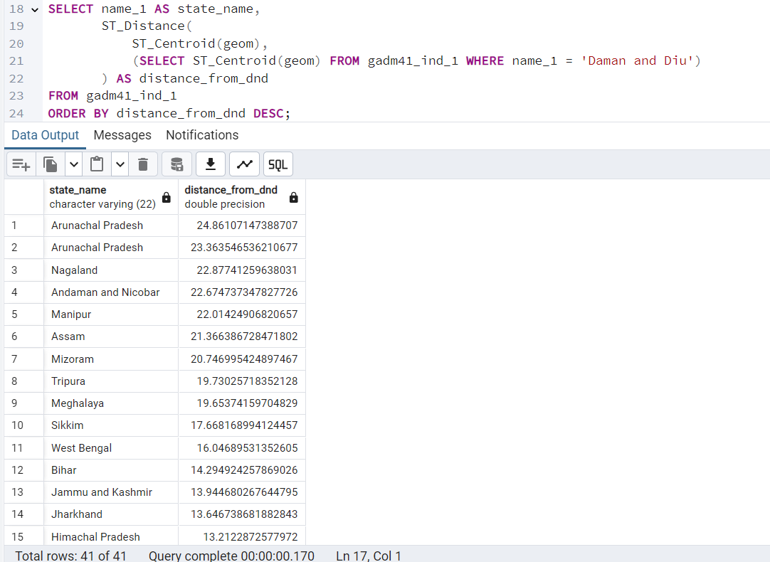 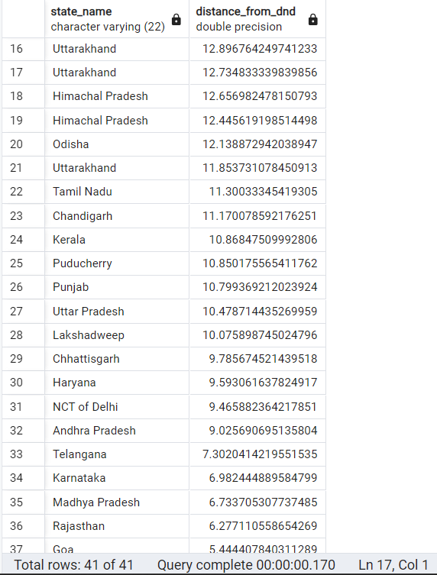

1. *Find the area of all the states.*

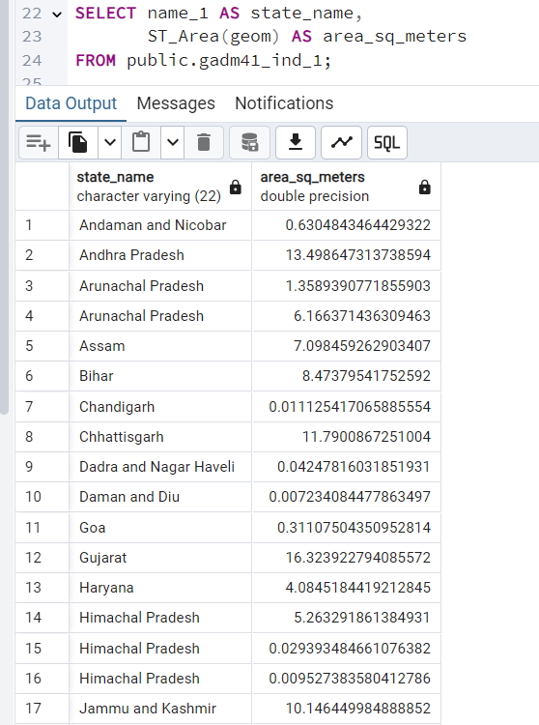 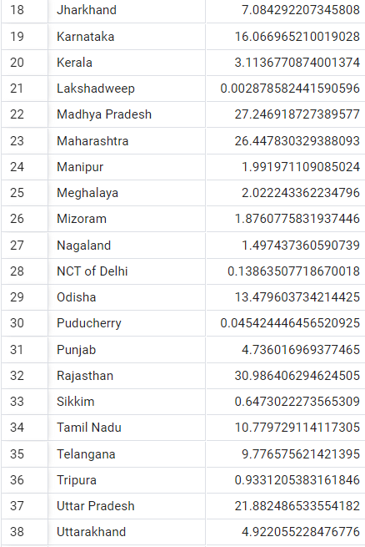

1. *List all states along with the number of neighbors they have in descending order with respect to the number of neighboring states.*

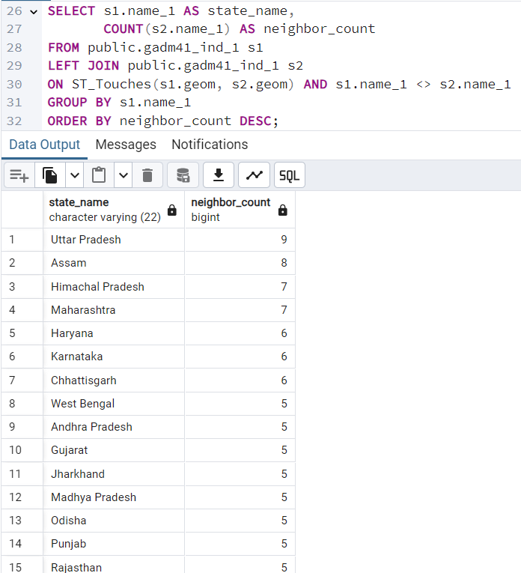 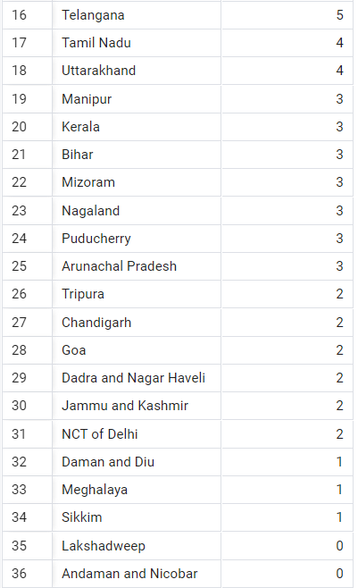

***Conclusion:***

*This experiment highlights the importance of accurate spatial reference systems (SRIDs) and geometry handling when performing spatial analyses in PostgreSQL/PostGIS.*

*1****. Spatial Reference System (SRID):*** *Initially, the geometries had an SRID of `0`, which meant they lacked a defined spatial reference. This led to inaccurate distance calculations, as the units were ambiguous. Assigning the appropriate SRID (`4326`) and transforming it to a meter-based SRID (`3857`) provided reliable units for distance measurements.*

*2.* ***Centroids vs. Full Geometry****: Using centroids for distance calculations initially provided an approximation, which may be sufficient for certain use cases. However, calculating distances based on the entire geometry (boundary-to-boundary) gave me more accurate results, especially when interested in distances between regions rather than single points within them.*

1. ***Choosing Appropriate Units****: By transforming the geometries to SRID `3857`, which uses meters, we could confidently set precise distance thresholds (like 100,000 meters for 100 km). This highlights the importance of choosing projections that match the measurement units required for spatial queries.*

***Mistakes I made :***

*- Always define an SRID for geometries to avoid ambiguous calculations.*

*- Choose centroid-based or boundary-based distance calculations based on the specific analysis needs. I chose boundary-based here.*

*- Use an appropriate projection (e.g., SRID `3857` for meters) when performing measurements in specific units, ensuring accurate spatial analysis.*